Practical 3:- API Integration and Data Rendering in React
Objective: | To consume a REST API in React and handle asynchronous data with loading and error states.
Problem Statement: | • Integrate a public REST API (e.g., GitHub API) into the portfolio application to fetch and display a list of repositories dynamically.  • Use the Projects page built in Practical 2 as the integration point.  • Implement a loading spinner component shown while the request is in progress.  • Implement an error message component shown if the API call fails.  • Render at least the repository name and URL for each item returned.
Implementation | Repository List:  import { motion } from 'framer-motion'  import { Folder, GitFork, Star, ExternalLink } from 'lucide-react'  import { FiGithub } from 'react-icons/fi'  const languageColors = {  Python: '#3572A5',  JavaScript: '#f1e05a',  TypeScript: '#3178c6',  C: '#555555',  'C++': '#f34b7d',  HTML: '#e34c26',  CSS: '#563d7c',  Jupyter: '#DA5B0B',  Dockerfile: '#384d54',  }  const RepoCard = ({ repo }) => {  const {  name,  html_url: url,  description,  stargazers_count: stars = 0,  forks_count: forks = 0,  language,  } = repo  return (  <motion.article  whileHover={{ y: -6 }}  transition={{ duration: 0.3, ease: [0.22, 1, 0.36, 1] }}  className="surface-raised group flex h-full flex-col p-6 transition-shadow duration-300 hover:shadow-hover"  >  <div className="flex items-start justify-between gap-3">  <div className="flex items-center gap-2.5">  <span className="btn-secondary inline-flex shrink-0 rounded-lg p-2">  <Folder className="size-4 text-bronze" />  </span>  <a  href={url}  target="_blank"  rel="noreferrer"  className="font-display text-base font-semibold break-all text-ink transition-colors hover:text-bronze-deep sm:text-lg"  >  {name}  </a>  </div>  <span  className="inline-flex shrink-0 items-center gap-1 rounded-lg bg-surface px-2.5 py-1 text-xs font-semibold text-ink-soft shadow-soft"  title="Stars"  >  <Star className="size-3.5 fill-bronze text-bronze" />  {stars.toLocaleString()}  </span>  </div>  <p className="mt-3 flex-1 text-sm leading-relaxed text-ink-soft">  {description || 'No description provided.'}  </p>  <div className="mt-5 flex flex-wrap items-center gap-3 border-t border-line pt-4">  {language && (  <span className="inline-flex items-center gap-1.5 rounded-md bg-surface px-2.5 py-1 text-[11px] font-medium text-ink-soft shadow-soft">  <span  className="size-2 rounded-full"  style={{ backgroundColor: languageColors[language] ?? '#a16207' }}  />  {language}  </span>  )}  <span  className="inline-flex items-center gap-1 text-xs font-medium text-muted"  title="Forks"  >  <GitFork className="size-3.5" />  {forks.toLocaleString()}  </span>  <a  href={url}  target="_blank"  rel="noreferrer"  className="btn-primary ml-auto inline-flex items-center gap-2 rounded-xl px-4 py-2 text-[13px] font-semibold transition-all duration-200 hover:-translate-y-0.5"  >  <FiGithub className="size-4" />  GitHub  <ExternalLink className="size-3 opacity-70" />  </a>  </div>  </motion.article>  )  }  const RepoList = ({ repos, hasRepos = true }) => {  if (repos.length === 0) {  return (  <div className="surface-raised px-8 py-14 text-center">  <p className="text-sm font-medium text-muted">  {hasRepos  ? 'No repositories match your search.'  : 'No public repositories found.'}  </p>  </div>  )  }  return (  <div className="grid gap-6 md:grid-cols-2">  {repos.map((repo) => (  <RepoCard key={repo.id} repo={repo} />  ))}  </div>  )  }  export default RepoList  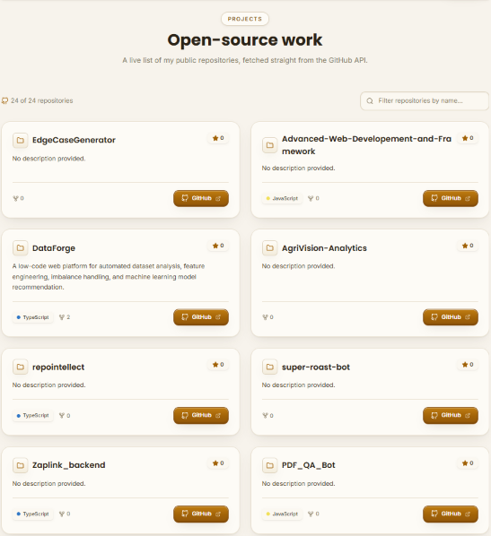
Outcome | Students will be able to consume a REST API in React, manage  asynchronous state correctly, and provide appropriate UI feedback during  all stages of a network request.

